Task 11.Use Tkinter module for UI design

Aim:
To use Tkinter module for UI design

Problem 11.1. Write a Python GUI program to create a label and change the label font style (font name, bold, size) using tkinter module.

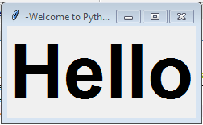

Algorithm:
- Import tkinter module
- Create a main window
- Create a label with desired text
- Add the label to the main window using pack() method
- Define a function to change font style
- Create a button to call the function when clicked
- Add the button to the main window using pack() method
- Start the main loop.

Program:
import tkinter as tk

# Function to change font style
def change_font():
label.config(font=("Arial", 18, "bold"))

# Create main window
root = tk.Tk()

# Create label with desired text
label = tk.Label(root, text="Hello, World!", font=("Helvetica", 14))

# Add label to main window
label.pack()

# Create button to change font style
button = tk.Button(root, text="Change Font", command=change_font)

# Add button to main window
button.pack()

# Start the main loop
root.mainloop()

Output:

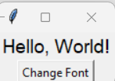

Task 11.2: Write a Python to Create a Basic Calculator App using the Tkinter module
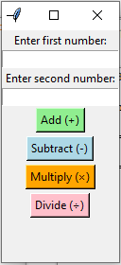

Algorithm:
- Start the program.
- Import the tkinter module.
- Create the main window using Tk().
- Add input boxes to enter two numbers.
- Create buttons for operations: Add, Subtract, Multiply, and Divide.
- When a button is clicked,
- Read both numbers from the input boxes.
- Perform the selected operation.
- Display the result in a label.
- Run the main loop to keep the window open.
- Stop the program when the window is closed.

Program:
import tkinter as tk

def add():
try:
result = float(num1_entry.get()) + float(num2_entry.get())
result_label.config(text=f"Result: {result}")
except ValueError:
result_label.config(text="Please enter valid numbers!")

def subtract():
try:
result = float(num1_entry.get()) - float(num2_entry.get())
result_label.config(text=f"Result: {result}")
except ValueError:
result_label.config(text="Please enter valid numbers!")

def multiply():
try:
result = float(num1_entry.get()) * float(num2_entry.get())
result_label.config(text=f"Result: {result}")
except ValueError:
result_label.config(text="Please enter valid numbers!")

def divide():
try:
num1 = float(num1_entry.get())
num2 = float(num2_entry.get())
if num2 == 0:
result_label.config(text="Cannot divide by zero!")
else:
result = num1 / num2
result_label.config(text=f"Result: {result:.2f}")
except ValueError:
result_label.config(text="Please enter valid numbers!")

# Create main window
root = tk.Tk()
root.title("Basic Calculator")

# Input fields
tk.Label(root, text="Enter first number:").pack()
num1_entry = tk.Entry(root)
num1_entry.pack()

tk.Label(root, text="Enter second number:").pack()
num2_entry = tk.Entry(root)
num2_entry.pack()

# Operation buttons
tk.Button(root, text="Add (+)", bg="lightgreen", command=add).pack(pady=2)
tk.Button(root, text="Subtract (-)", bg="lightblue", command=subtract).pack(pady=2)
tk.Button(root, text="Multiply (×)", bg="orange", command=multiply).pack(pady=2)
tk.Button(root, text="Divide (÷)", bg="pink", command=divide).pack(pady=2)

# Result label
result_label = tk.Label(root, text="", font=("Arial", 12, "bold"))
result_label.pack(pady=10)

root.mainloop()

Output:

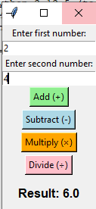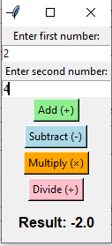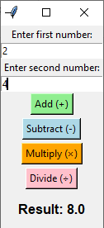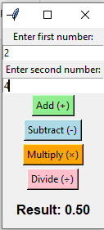

Result: Thus the Program using Tkinter module for UI design was executed and verified successfully.

